**How To Type Spanish Accents/Symbols on a PC Desktop, Laptop, or MAC**

From: <http://tlt.its.psu.edu/suggestions/international/bylanguage/spanish.html>

**On PC desktop:** **:** You can try clicking on **Insert** then **Symbol** in Word **OR** Hold the **alt** key while typing in the numbers listed below for each symbol.

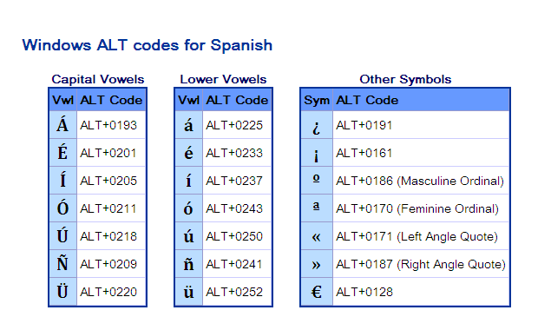**On PC laptop:** **:** You can try clicking on **Insert** then **Symbol** in Word **OR** Hold the **fxn** key and the **NmLk** button (sometimes also dually marked as ScrLk) to set the number lock buttons on the laptop. Look on the keyboard to see which keys have the numbers on it at the bottom corners (that becomes the number pad that is usually found on the side of a desktop). While that is activated, you can follow the instructions for the desktop (hold the alt key While typing in the numbers listed below for each symbol).

**On a MAC:** You can try clicking on **Insert** then **Symbol** in Word **OR** you can use the **Option+E** key + the desired **vowel** (either lowercase or uppercase) to make the á/Á,é/É, í/Í, ó/Ó, or ú/Ú. Refer to the table below for more details and additional symbols.

|  |  |
| --- | --- |
| **Macintosh Option Codes for Spanish** | |
| **Character** | **Description** |
| **Acute Accent (e.g.Ó)** | Type **Option+E**, then the vowel. For instance, to type **á** hold down **Option+E**, then type lowercase **A.** To type **Á,** hold down **Option+E**, then type capital **A**. |
| **Ñ,ñ** | Type **Option+N**, then either lowercase **N** for **ñ** or capital **N** for **Ñ.** |
| **Ü, ü** | Type **Option+U**, then either lowercase **U** for **ü** or capital **U** for **Ü.** |
| **¿** | **Shift+Option+?** |
| **¡** | **Option+1** |
| **º, ª** | **Option+0** (Masculine Ordinal Number Marker) **Option+9** (Feminine Ordinal Number Marker) |
| **«, »** | **Option+\**   **Shift+Option+\** (Double Angle Quotes) |
| **€** | **Shift+Option+2** (may not work for older System 9 fonts) |